Institute of Technology of Cambodia

Department of Information Technology   
and communication

Operating System

Name of students ID of students

1. Pheng Menghour e20210737

Lecturer: Mr. Heng Rathpisey

Academic Year 2024-2025

TP1

1. You are required to have an **Ubuntu operating system**.
2. If your PC is operated by any Ubuntu, take a screenshot of “**About**” which includes name and version of your current Ubuntu.
3. If your PC is operated by any Microsoft Windows or Apple macOS, please use any virtual machine tool to install **Ubuntu**, and take a screenshot of “**About**” which includes name and version of your current Linux.

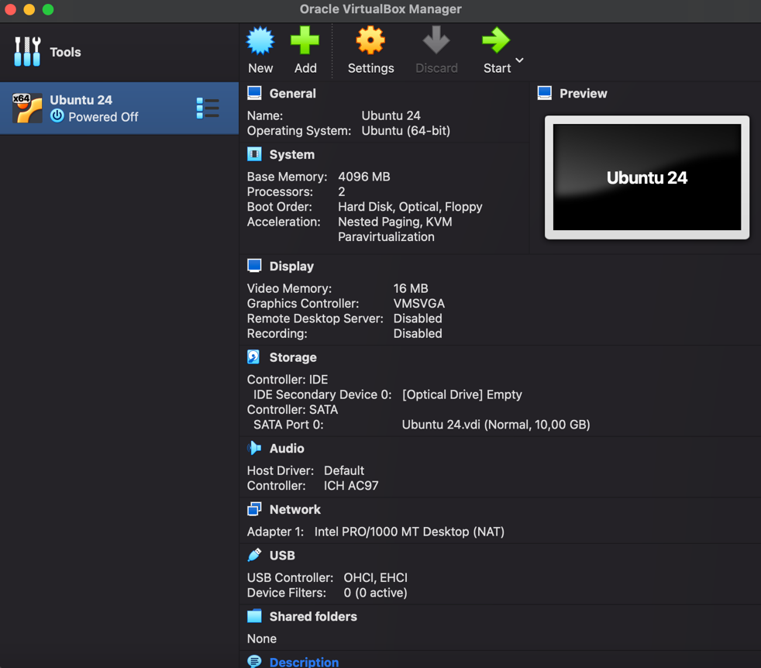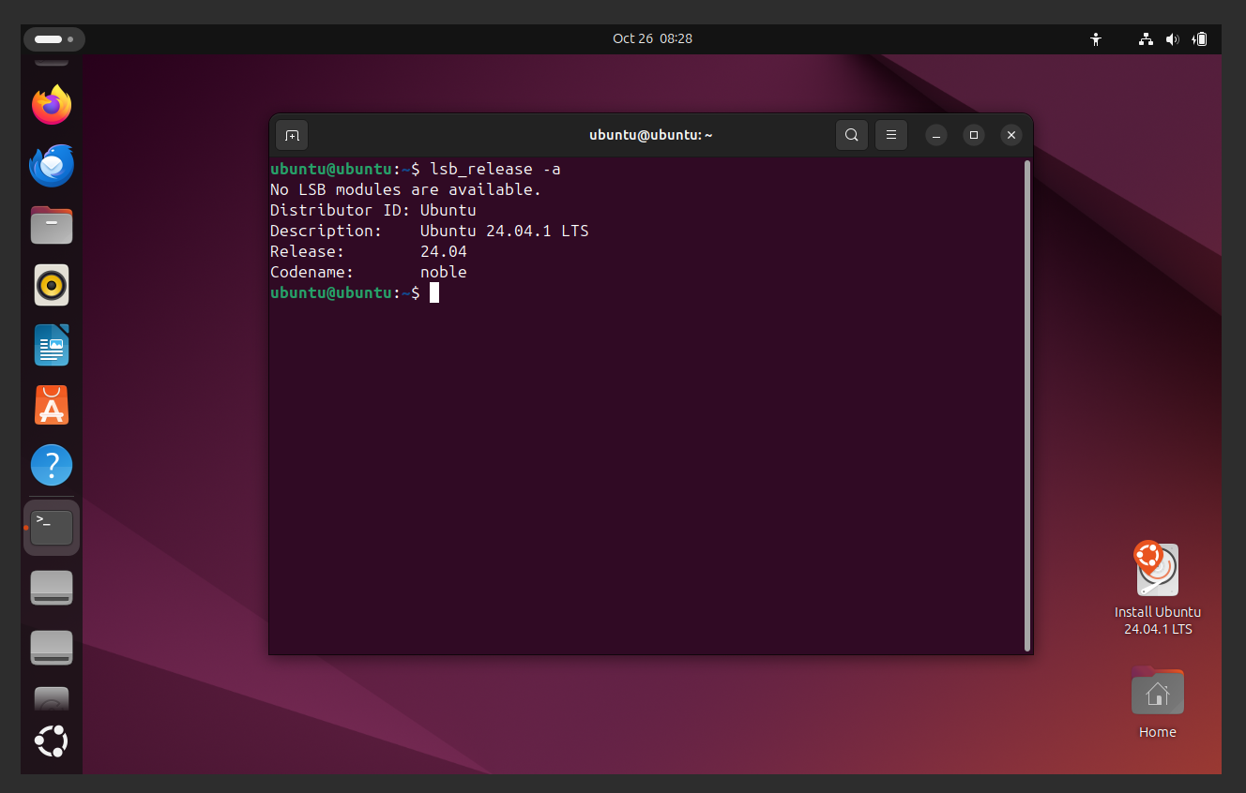

1. Basic Linux:
2. ls
3. whoami
4. pwd
5. history
6. Shell variables: echo $HISTSIZE, $USER, $PATH
7. man
8. Control statements: ; && ||
9. mkdir, touch

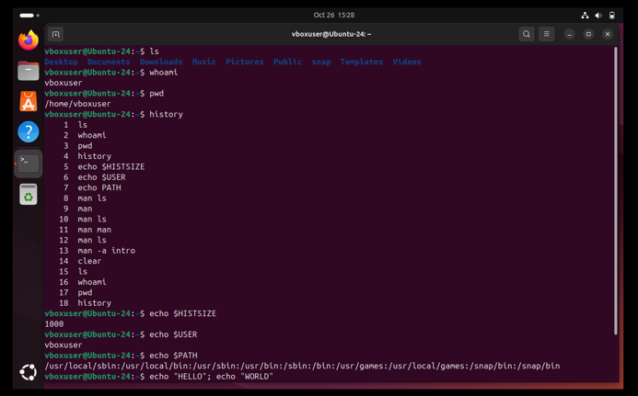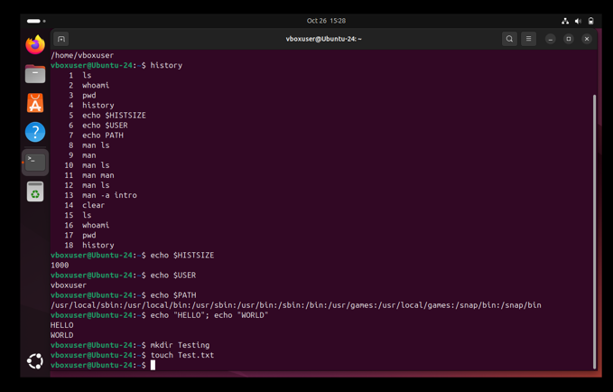

1. **Scenario Exercise:**

Task: Organize your files and gather information about your system.

1. File Organization

*Create a directory named LabFiles.  
Inside LabFiles, create two files: doc1.txt and doc2.txt. List the contents of LabFiles to confirm the files' existence.*

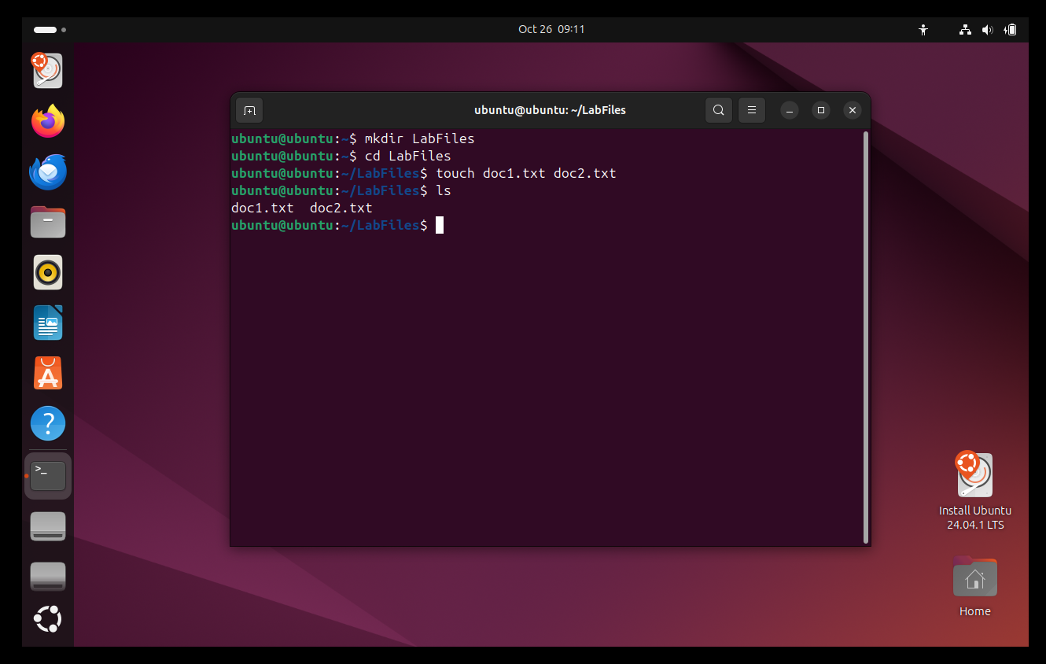

1. System Information Gathering

*Check who the current user is.  
Determine the current working directory.  
Print the last five commands you have used.  
Display your shell's command history size.  
Check the directories included in your system's PATH variable.*

*Find 5 most used Environmental Variable and display their values*

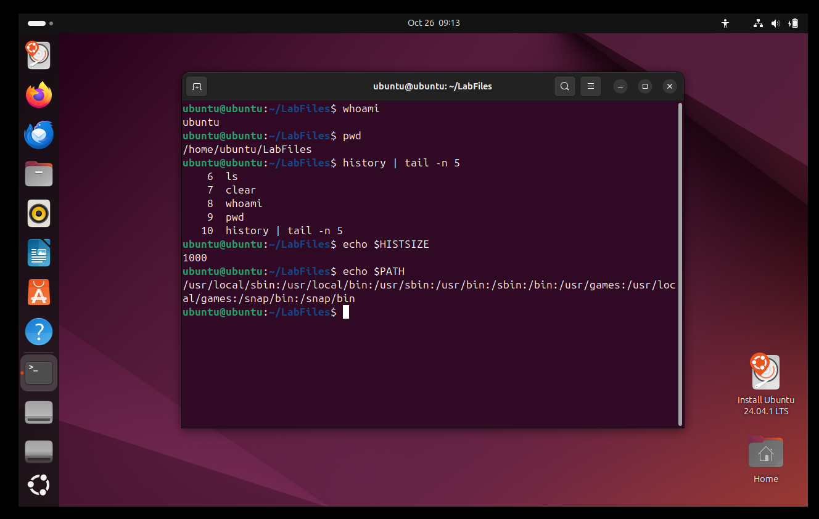

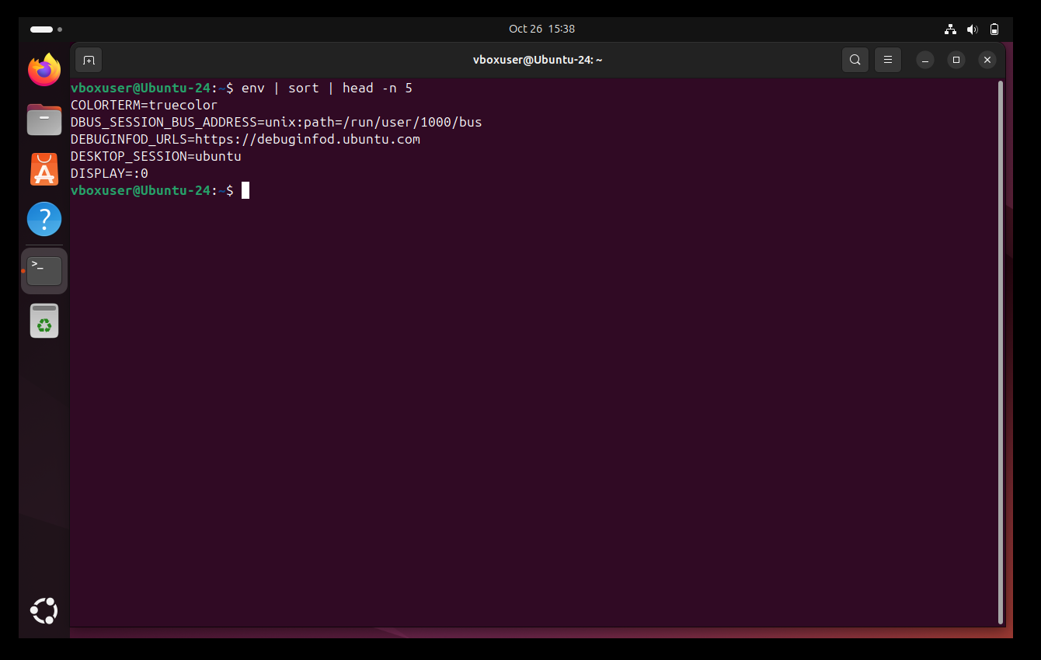

1. Documentation

*For each command used,  
Screenshot the result from running the commands.  
Include examples of control statements used during the exercise.*

1. Task: Install, verify, and remove a software package.

**Installation Task**

1. Update your package lists. 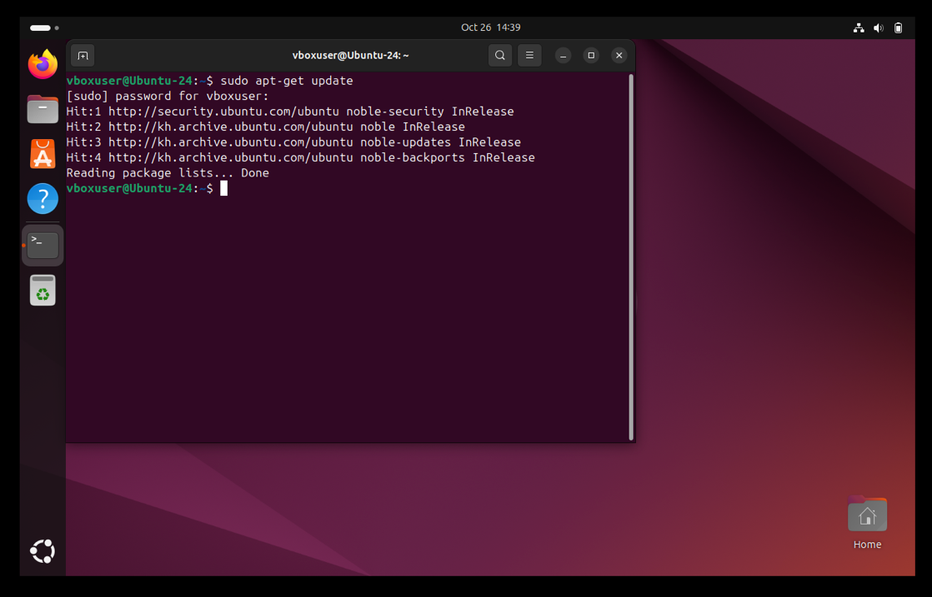
2. Install the c compiler gcc using *sudo apt-get install gcc*.

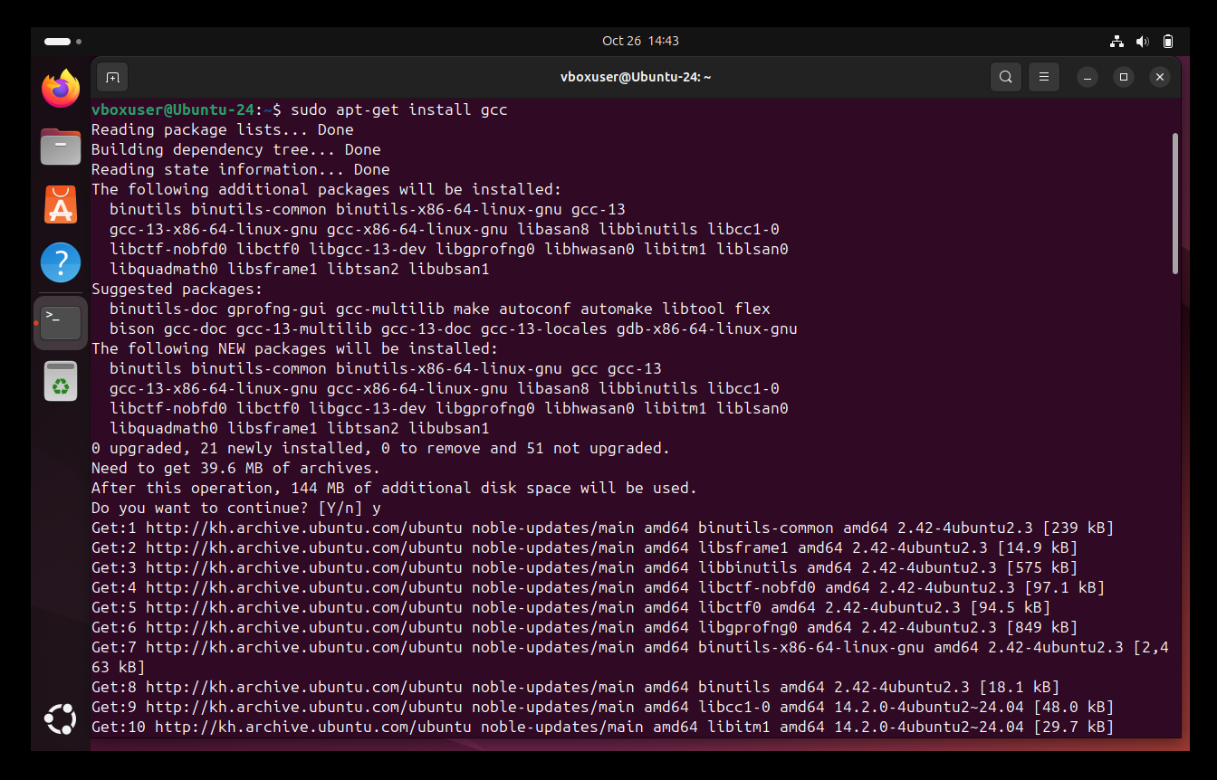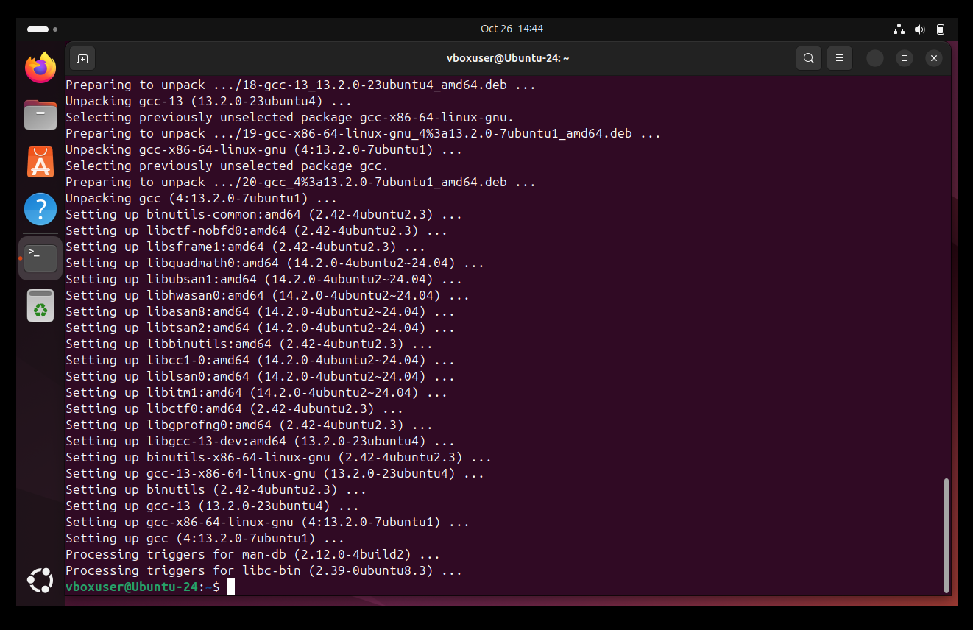

1. Experiment with installing a different version of a common package, such as python.

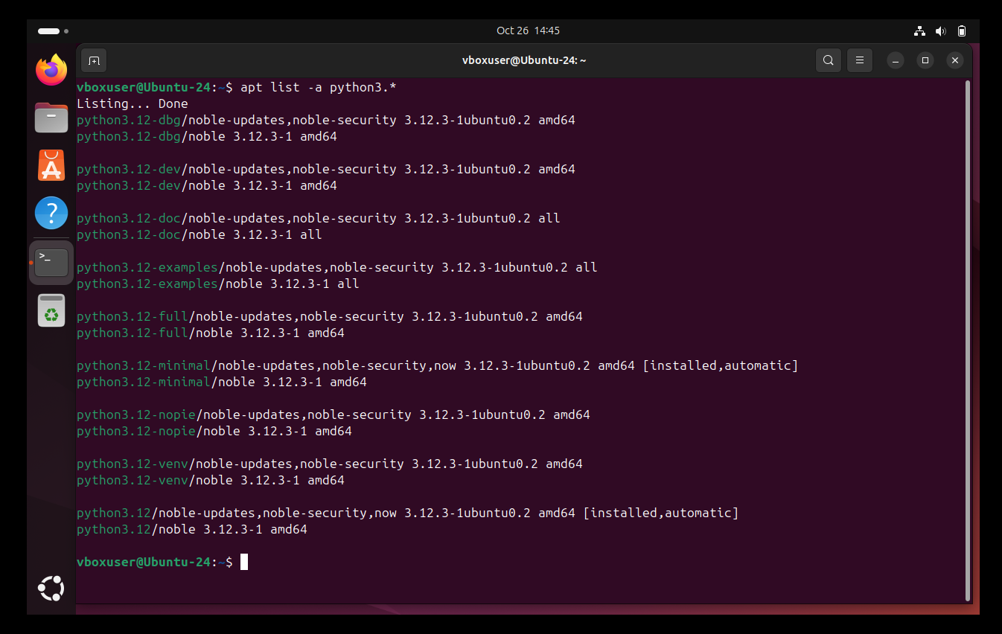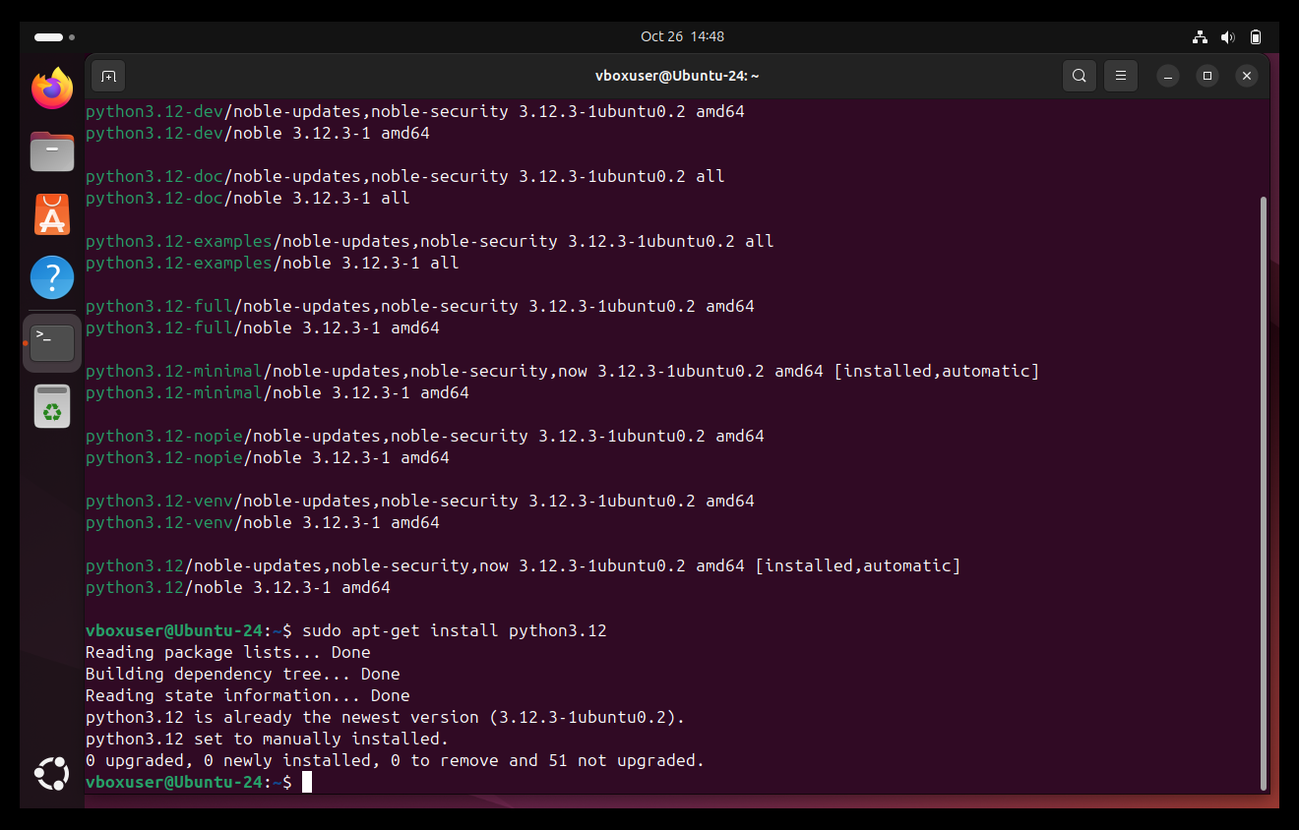

**Removal Task**

1. Remove nano using *sudo apt-get remove nano.*

